Fishponds and the consumption of freshwater fish: from medieval status symbol to garden ornament, c. 1550-1750
By David G. Bate, Jan 2002
Introduction … … … … … … 2
The period before 1550 … … … … … 2
Post medieval decline … … … … … 5
Some principal cultivated freshwater fish … … 8
Conclusions … … … … … … 13
Notes … … … … … … … 14
List of references … … … … … 16

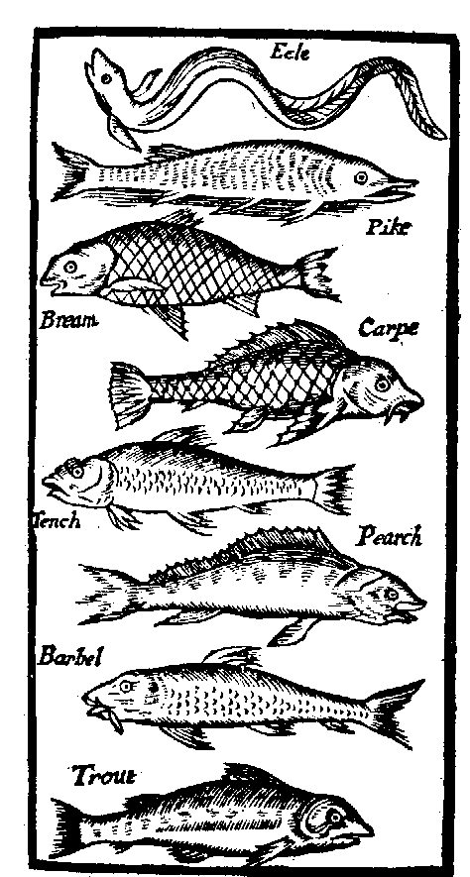
Illustration from an early cookery book: H. Woolley, The accomplish’d ladies delight. 6th ed. (London, 1686)
Introduction
There is plenty of evidence to indicate that the eating of freshwater fish in medieval England was associated with privileged status. However, the importance of freshwater fish as an aristocratic food source suffered a gradual decline in the post-medieval period. This decline is indicated in part by the changing function of artificial fishponds from objects of utility to ornamental water features in the period c.1550 to 1750. The special status accorded to freshwater fish in the Middle Ages is indicated both by the widespread field evidence for fishponds (not considered here) and by the abundant contemporary documentation relating to royal, episcopal and monastic fisheries. Documentary evidence for the post-medieval period is more scarce however.

The period before 1550
“Freshwater fish [in medieval England] must be regarded primarily as part of the diet of the aristocracy. This is indicated clearly enough by the frequency with which ponds are found in association with moated sites, castles and monasteries, or within parks.” (Dyer 1988)
In England fishponds have been kept both for profit and pleasure since at least the Roman period (Zeepvat 1988). It was in the Middle Ages however that the consumption of fish, and in particular pond fish, became both a feature of significance and a status symbol in English society. The importance of fish in the medieval aristocratic diet was in part due to the dietary rules enforced by the Church. It was thus forbidden to eat meat on Fridays and Saturdays, during the six weeks of Lent, and on the vigils of important festivals such as Christmas Eve; in some instances Wednesdays also were observed. The tradition of eating fish on specified days has a pre-Christian origin, but the dictates of monastic life from about the sixth century served to reinforce its more rigid adoption in medieval society.¹ The resentment that was no doubt felt by many at this enforcement is illustrated by some lines from the fourteenth century poem, Sir Gawain and the Green Knight:
After Crystenmasse com the crabbed lentoun,
that fraystez [tries] flesch wyth the fysche and fode more symple.²
Supplies of fish could be obtained from sea fisheries, natural lakes and marshlands, river fisheries, eel-traps in mill streams, and artificial fishponds. Those who owned fishponds had the important advantage of being assured a regular and reliable supply of fresh fish unaffected by seasonal and other vagaries. The construction and maintenance of private fishponds however required a high level of investment that was available only to a wealthy minority. Ponds were used for breeding or rearing, and for storage, the two functions being usually kept distinct. The latter type were commonly called ‘stews’ and were effectively holding ponds in which to store live fish ready for the table.³
Dyer (1988) has made much use of medieval household accounts in helping to assess the significance of freshwater fish in aristocratic diet. The evidence of these accounts shows that sea-fish were generally consumed in much larger quantities than freshwater fish. As an example, the accounts of the household of the Bishop of Coventry and Lichfield, John Hales, show that for a four-month period in 1461 he and his household consumed 639 sea-fish, compared with 258 freshwater fish. However, the freshwater fish (obtained mostly from demesne ponds or as gifts) were valued by the Bishop at £1 7s 1d, compared with the sum of £1 4s 6½d that was paid by his steward for the sea-fish (probably purchased at Lichfield). It is clear from these and other accounts that freshwater fish commanded relatively high prices compared with sea-fish. The following table shows prices and valuations of fish (each) in 1461 based on Hales’s accounts (Dyer 1988, p. 31):
Sea-fish |  | Freshwater fish
Species/type | Median price | Species/type | Median valuation
Salt-fish | 8d | Pike | 12d
Stock-fish [dried cod] | 3d | Pickerel [young pike] | 8d
Herring | ¼d | Bream | 5d
Plaice/flounder | ½d | Tench | 6d
 |  | Perch | 2d
 |  | Chub [river] | 4½d (price)
 |  | Eel | 1½d

The frequent medieval practice of making gifts of freshwater fish is a clear indication of the high esteem in which they were held. Such gifts might be made to gain favour with those in positions of power or influence. Thus Dyer (1988, p. 34) cites the example of the Mayor of Leicester who in 1346 gave the overlord of the town, the Earl of Lancaster, a dozen pike, bream, lampreys, eels and salmon amongst other things. Royal gifts of breeding fish were frequently distributed as rewards for services, and the Close Rolls record many such gifts of bream, pike, roach and tench from various royal ponds during the thirteenth century (Steane 1988, pp. 52-66).
A further indication of the high status of freshwater fish can be gauged from the great size and complexity of royal, episcopal and monastic fishponds, while by far the most numerous class of fishponds were those attached to the estates of the landed upper classes. The remains of such ponds are perhaps one of the commonest forms of medieval earthwork in the English Midlands.
It has been asserted that fish farming was of probably greater significance during the Middle Ages than the breeding of rabbits or deer, vying even with forestry for importance (Taylor 1988). Yet according to Davis (1966, p.14) it was rare even by the late Middle Ages to find freshwater fish available on the open market. There was certainly a substantial trade centred in London from at least the early fifteenth century (Dyer 1988) although it must have served an exclusive market. From the late fourteenth century many landowners had been obliged to lease out their ponds and fisheries to tenant farmers who could sell their catches to fishmongers.⁴ Royal instructions issued to the Lord Mayor of London in 1522 for the state visit to England of Emperor Charles V required him to “assigne ij fysshmoungers for provision of … pykes, tenches, bremes, caver [fresh] salmon, and such oder deyntes of the fresshe water” (Jerdan 1842, p. 84). Outside of London the situation was rather different, and a memorandum relating to preparations for the Emperor’s subsequent progress between Windsor and Southampton includes the item, “lettres to be sent to diverse gentlemen for pykes, bremes, tenches, carpis, trowttes, rosting elis, and suche other deyntes as they have in their ponds and fresche rivers” (Jerdan 1842, p. 100).
The requirement for freshwater fish appears to have continued unabated until the sixteenth century, and the general consensus is that it declined in importance thereafter. The great royal fishponds of which at least 36 separate complexes can be accounted for by the fourteenth century were already falling into disuse by the late Middle Ages. The reasons for this are set out by Steane (1988, pp. 50-51), but it is evident that the royal household came to depend on the London fishmongers for the provision of much of its freshwater fish.⁵ The fate of monastic fishponds following the Dissolution is less clear, but the great expense of maintaining them would have ensured that many fell into disuse.

Post medieval decline
“. . . the status symbol of freshwater fish remained until the end of the Middle Ages and beyond. When and why did this feature of the English aristocratic lifestyle die out?” (Dyer 1988)
After the Reformation the maintenance of fish days was encouraged and even enforced under Elizabeth I, avowedly for the protection of marine fishermen and to reduce the consumption of mutton.⁶ In the particulars of account of the judges of assize for the Western and Oxford circuits, from 1596 to 1601, we find recorded frequent ‘presents’ from various local dignitaries of, amongst other things, freshwater and sea-fish. The accounts give a useful indication of the relative quantities of the different varieties of fish that were consumed at this period. The following table is based on a rough count of freshwater fish itemised in the accounts as published by Cooper (1858):
Species |  | Number ‘presented’
Carp | 216
Trout | 191
Salmon | 71 |  | described either as fresh (63) or salt (8)
Pike | 60
Eel | 56 |  | including 20 salt, 6 ‘Holland’ and 3 ‘Flanders’
Roach | 46
Perch | 34
Tench | 28
Bream | 27
Dace | 4
Lamprey | 1 |  | also 5 lamprey pies
Barbel | 1
The most frequently presented sea-fish was the whiting (183), followed by herring (135) and plaice (120). Of particular note here is the greater significance given to carp and trout. The latter, together with salmon, would have been primarily river catches, but there is evidence that by the late sixteenth century trout could have been stored in large ponds adjacent to rivers (Taverner 1600).⁷ The carp was introduced from Europe in the mid fifteenth century and seems to have gradually supplanted the bream in popularity owing to its hardiness and faster growth. Indeed, it would appear that by the first half of the seventeenth century the carp had become so popular a fish for the table that one contemporary writer was prompted to remark that “most of our Country Gentlemen … store their ponds almost with no other fish” (Burton 1651).
In the early seventeenth century the household treasurer of the Earl of Rutland at Belvoir Castle regularly purchased live freshwater fish from one Paul Robinson, a fisherman who procured his catches from the rivers of the Holland district of Lincolnshire. He states in 1612 that fish could be purchased in two sizes, a larger size ready for the table (‘present service’) and a smaller size for stocking (Davis 1966, p. 128): ⁸
Species | for store |  |  | for present service
 | size | price |  | size | price
Pike | 20 inches | 2s |  | 24 inches | 2s 6d
Bream | 20 " | 2s |  | 24 " | 2s 8d
Tench | 14 " | 6d |  | 16 " | 9d
Carp | 10 " | 12d |  | 18 " | 2s
The cost of a serviceable pike at 2s 6d is equivalent to about £10.60 at today’s prices. This should be compared with Bishop Hales’s valuation of 12d for a pike in the mid fifteenth century (see earlier table), which equates with about £20 at current prices. Furthermore, Dyer (1988) records that a ‘mature’ pike in the fifteenth century could fetch as much as 3s, or £60 at today’s prices. A similar picture emerges for tench of serviceable size, where we find equivalent values of £3.50 in 1612 compared with £10.15 in 1461. Although these comparisons provide limited evidence they do seem to demonstrate a considerable diminution in the value, and therefore luxury status, of at least some freshwater fish in the post medieval period. An exception would appear to be the bream, which shows an increase in equivalent value from £8.15 in 1461 to £11.50 in 1612. This might indicate that the displacement of the bream by the carp had more to do with economic considerations than with consumer preference. At any rate, the bream perhaps remained a favoured fish in certain aristocratic households because of its former importance at the royal table. In terms of price the carp appears in 1612 to have been as expensive for its size as either bream or pike, and more expensive than tench.
From the end of the sixteenth century and into the early eighteenth century there appeared a number of manuals and treatises aimed at promoting the construction and maintenance of fishponds.⁹ Probably the best of these was by John Taverner (1600) Surveyor General of the king’s woods south of the Trent, who recommends carp, bream, tench and perch as the best fish for pond cultivation. An important but costly aspect of successful freshwater fish cultivation in the Middle Ages had been the regular draining and cleaning of ponds in order to keep them free of mud, weed and disease. This appears to have operated on a five-year cycle based evidently on the time taken for bream to reach maturity. But by the time the Dutchman, Janus Dubravius was writing in 1563 (translated into English in 1599) a three-year cycle was being recommended based on the faster growth rate of the carp (Currie 1991). Taverner intimates however that there had been a decline in pond maintenance by the end of the sixteenth century. He remarks that “fish that is kept in a standing pond without feeding or other industrie” will be poor in taste “and I suppose that this is the cause that most men are out of love with all pond fish, because they never tasted of any good or well ordered pond fish”. It appears also by this period that fish was no longer the only food consumed on fish days, or “spent upon the dayes by law ordained for that purpose in this Realme”, for Taverner goes on to complain that “now those that would spend such fish, will rather bestow their money on Rabbets, Capons, or such like”.
Under the Commonwealth, fish days were abolished as a Popish institution and although efforts were made to reintroduce them following the Restoration (as a means of encouraging the fishing industry) the attempt seems to have met with little success (Wilson 1973, p. 46). In the early eighteenth century we find Roger North in his Discourse of fish and fishponds, published in 1713, lamenting that many rural estates were being leased to tenants who were neglecting their fishponds (Currie 1991, p. 105). Ponds continued however to be made, extended or maintained during this period, but gradually they came to assume a more ornamental function. In Oxfordshire for example a number of fishponds that are believed to be of post-medieval date exhibit a marked ornamental component (Bond & Chambers 1988). By the eighteenth century this ornamental aspect had assumed some dominance, although fish culture was not entirely subsumed. The role of fishponds as garden features during the period c.1550-1750 has been treated at some length by Currie (1990).

Some principal cultivated freshwater fish
“Ancolme ele, and Witham pike,
Search all England and find not the like”
(old Lincolnshire proverb, cited in Phipson 1883)

In this section brief descriptions will be given of some of more important cultivated freshwater fish together with comments on their varying status as a food source. The only significant pond fish here omitted, for reasons of space, is the roach. Illustrations are taken from Maitland (2000), while factual details, where not credited, are mostly derived from Maitland & Campbell (1992).

European Eel (Anguilla anguilla)
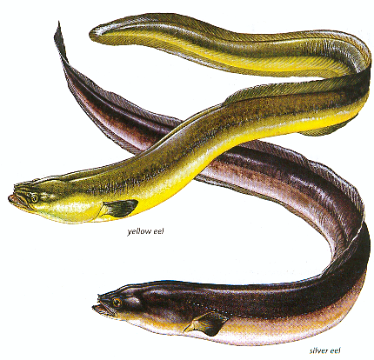

The adult eel occurs in most freshwater habitats (helped by its ability to leave water and wriggle across wet ground in search of isolated sites) but requires access to the sea in order to spawn. The young fry migrate into fresh waters as elvers and mature as ‘yellow eels’, then migrating after some years as ‘silver eels’ back to their spawning grounds in the Sargasso Sea. The eel was probably the most widely consumed of all freshwater fish, being available or affordable to rich and poor alike. Eel fisheries were important in the early medieval period and eel rents were a common form of manorial payment in the East Anglian fens. Great numbers of eels were imported from the Low Countries all through the Middle Ages (Wilson 1973) and at least into the early post-medieval period (see table p. 5). Although ponds were commonly stored with eels, the great majority of those consumed were probably direct river catches. Izaak Walton (1676) records how in Staffordshire many of the “poorer sort of people” would capture the migrating elvers with sieves or sheets to make “a kind of eel-cake of them” which they would eat “like as bread”. And the 1748 edition of Daniel Defoe’s Tour through Great Britain records that the small town of Keynsham on the River Avon was a commercial source of elver cakes, which were sent to Bath and Bristol (Grigson 1993).
Walton it seems expressed the view of “most men, that the Eel is a most daintie fish; the Romans have esteemed her the Helena of their feasts, and some The Queen of palat pleasure”. Today however the eel is but little esteemed in most parts of Britain, although an annual elver-eating competition is still held at Frampton-on-Severn in Gloucestershire (Grigson 1993). In northern Europe smoked eel is regarded as a luxury item.

Common Bream (Abramis brama)
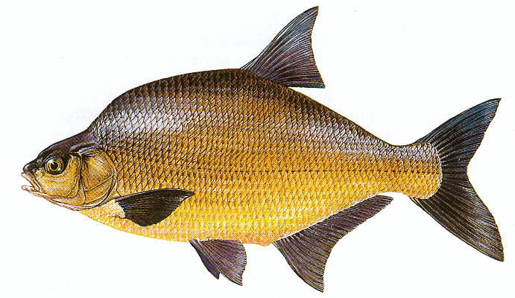
The bream is a slow-growing fish, taking up to five years to reach a size suitable for harvesting. It was the staple fish for most medieval ponds and seems to have been in great favour at the royal table in the thirteenth century, being probably the most frequently mentioned fish in the Close and Liberate Rolls. Samson de Bremesgrave, who is recorded in the thirteenth century carrying bream from the royal ponds at Feckenham in Worcestershire to the king at Westminster, appears perhaps from his name to have been charged with some regular office in connection with the provision of this fish.¹⁰ The bream’s popularity continued at least into the first half of the seventeenth century, when we find Gervase Markham recommending it in his English husbandman published in 1613. It was however eventually displaced by the economically more attractive carp. Thus in 1686, Lord Wharton’s detailed account of the numbers of fish drawn from his several ponds in the manor of Upper Winchendon in Buckinghamshire makes no mention of the bream, while recording many hundreds of carp and a good number of tench (Croft & Pike 1988, pp. 264-5).
By the nineteenth century the bream had gone out of repute as a table fish. Mrs Beeton makes no mention of it in her Book of household management of 1869 (Chambers & Gray 1988), while modern fish cookery gives it no more than passing notice (e.g. Grigson 1993).

Common Carp (Cyprinus carpio)
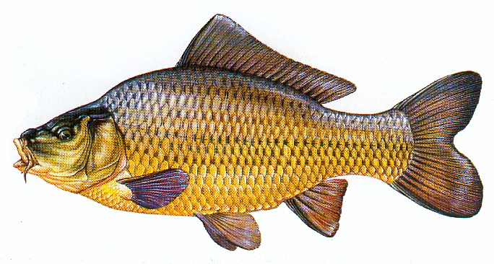
The carp is not native to Britain but was introduced from Europe. The earliest British record of carp being stocked in ponds is said to date from 1462, when the Duke of Norfolk stored his ponds with them, subsequently making gifts of live carp to several of his wealthy neighbours (Currie 1991, p. 102). The carp became in due course an alternative to the bream, since edible fish can be produced in three years rather than five (both fish are members of the family Cyprinidea, as indeed are tench and roach). Currie (1991) has made a strong case for a largely commercial basis to the introduction of the carp into England. Contemporary accounts relating to the stocking of ponds with carp become common in the 1530s. Prior William More of Worcester stocked his ponds on a trial basis in 1531 but evidently treated carp as a novelty at this time (Hickling 1971). Certainly by the early seventeenth century the carp had become the most popular freshwater fish in England. Roger North records in 1713 that the carp was in great demand in London, where a fish between thirteen and sixteen inches could be expected to command a price of 12d (Currie 1991, p. 105) or about £3.40 at today’s prices. This is a fairly significant reduction in price compared with the sums that were being paid one hundred years earlier by the Earl of Rutland’s household treasurer. At that time a live carp of ten inches (lengths were usually recorded from between the eye to the fork of the tail) sold for an equivalent price of £4.30 while a fish of eighteen inches sold for £8.50 (see table p. 6). It would thus appear by 1713 that commercial enterprise had succeeded in making the carp a more affordable commodity for a wider range of consumers.
The carp is said to be “fairly good eating when well cooked, but all the recipes seem to agree in recommending the use of plenty of wine and other accessories which disguise the muddy flavour of the fish” (Regan 1911).

Tench (Tinca tinca)
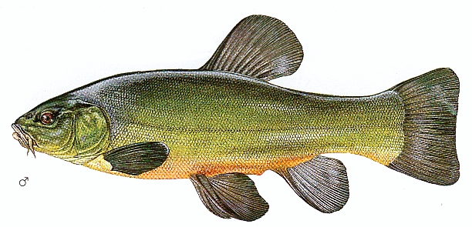

The tench is a fish extremely tolerant of stagnant conditions and thus well suited for storing in even the smallest of manorial ponds. It has long been appreciated however that fish “such as are bred in muddy and standing waters … taste of mud” (Burton 1651). This warning applies particularly to the tench and explains no doubt the varying reputation of this fish. The Romans had a poor opinion of tench, yet it was undoubtedly prized for the table all through the Middle Ages. T. Muffett in his Health’s improvement of 1655 says of the tench that “His flesh is stopping, slimy, viscous & very unwholesome; and … of a most unclean and damnable nourishment” (cited in Bond 1988, p. 94). Walton (1676) seems likewise unable to commend this fish. Mrs Beeton on the other hand, writing in 1869, considered the tench to be “esteemed in England as a delicious and wholesome food” (Chambers & Gray 1988). Few people however would consider eating tench today, and it receives barely a passing notice in modern fish cookery (e.g. Grigson 1993).

Pike (Esox lucius)

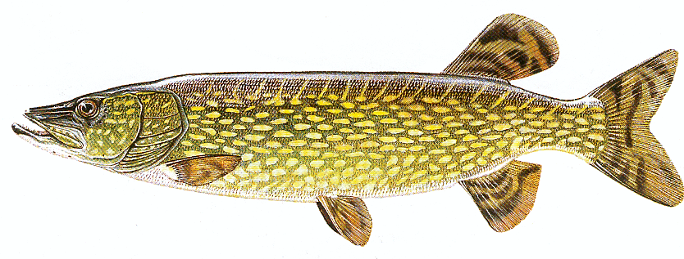

“The mighty Luce or Pike is taken to be the Tyrant (as the Salmon is the King) of the fresh waters”. So says Walton (1676) in his introduction to this singularly ferocious fish. Pike, along with bream, is one of the most frequently recorded fish in medieval accounts. In the thirteenth and early fourteenth centuries the royal fishponds at Woodstock in Oxfordshire were stocked almost exclusively with pike (Bond & Chambers 1988, p. 365). The very high prices paid for pike in the Middle Ages may have been due to its scarcity in the wild, although it has since been introduced into most parts of Britain. Taverner (1600) recommends that pike be stored separately from other fish in “some ditch or small stew” where it might be fed with unwanted bream and carp fry, for “The Pike will grow exceedingly, if he have his fill of other small fish: as, the first yeare to twelve or fourteen inches, the next to twenty or two and twenty inches”.
The flesh of pike has a distinctive flavour which by some is considered a great delicacy and by others as unpalatable. Izaak Walton gives detailed instructions for preparing and cooking the pike, but concludes that “This dish of meat is too good for any but anglers and very honest men” (Walton 1676).

Perch (Perca fluviatilis)
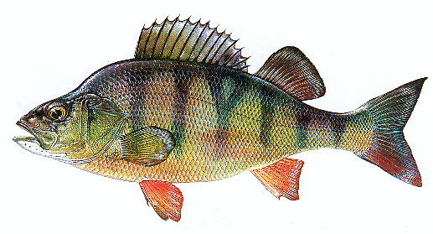

The perch is considered by some to be second only to salmon in its excellence for the table, and though troublesome to prepare it is “clean, firm, and white, destitute of that insidious earthy flavour to which fresh-water fish are so prone” (Maxwell 1904). The philosopher, Sir Thomas Browne declared in his Religio medici, published in 1635, that perch taken in Breedon Broad, Norfolk, “make a dish very dainty, and scarce to be bettered in England” (cited in Maxwell 1904, p. 59). Taverner (1600) considered the perch to be a useful scavenging fish because it helps prevent ‘overstoring’ (a particular problem with bream) by consuming excess fry.

Conclusions
The special status accorded to freshwater fish in the Middle Ages is demonstrated by their disproportionately high prices, particularly when compared with sea-fish, and their use as gifts by the king and various high officials. As Aston (1988) has pointed out, “this is perhaps more surprising when in general freshwater fish are reckoned to be less appetising, without elaborate preparation and seasoning, than sea fish”. But aristocratic households could afford the ‘elaborate preparation’ that might be needed to make freshwater fish more palatable, while careful management of fishponds in the Middle Ages would have ensured that fish were sweeter and more delicately flavoured.
After the late fourteenth century aristocratic consumers became increasingly reliant on the market as demesne gave way to leasehold farming. The new tenants ― lesser gentry and rich peasants ― appear either to have neglected their fishponds or turned them to profit. The introduction of the carp into England in the mid fifteenth century provided the potential for commercial exploitation, although it was initially slow to gain acceptance. But the hardiness of the carp, the ease with which it could be transported, and its rapid growth rate ensured that by the beginning of the seventeenth century it was being fairly widely cultivated. As Currie (1991, p. 101) has observed, “fish culturists know only too well [that] the quicker a fish will grow, the more money there is to be made”. As fresh-water fish became more widely available to the populace, so must its status as a luxury food item have become somewhat diminished, although it was always more expensive than sea-fish. Those manorial and sub-manorial tenants who opted to exploit their fishponds during the sixteenth and seventeenth centuries may have taken advantage of the carp’s tolerance by skimping on such essential expenses as pond draining and cleaning. Taverner’s melancholic remarks at the beginning of the sixteenth century on the dire consequences of such poor husbandry have already been cited (above, p. 7).
The abolition of fish days under the Commonwealth must undoubtedly have assisted the decline in fish consumption generally, and of freshwater fish in particular. It is hardly surprising therefore that by about the middle of the eighteenth century most tenants and landowners had allowed their fishponds to lapse into merely ornamental features, a process that had already begun in the late sixteenth century.

Notes
¹ Indeed, monastic life under the Benedictine rule required those that were not infirm to abstain completely from eating the flesh of all four-footed beasts, although from the beginning of the thirteenth century this rule was often flouted (Bond 1988).
² Cited by Moorhouse (1988), but here given in its original Middle English (Tolkien & Gordon 1967, p.15).
³ Some modern authorities (e.g. RCHM 1979; Currie 1990) consider that stew ponds were used originally for intensive breeding rather than for storage. The Oxford English Dictionary (2nd ed. 1989) is quite explicit however in defining ‘stew’ in the same sense as the French estuier, to shut up or keep in reserve. Interestingly, the expression aliquo stuo, translated by Steane (1988, p. 46) as ‘store pond’, occurs in a royal request that was sent to the Archbishop of York in about 1251-3, in which he is asked to make provision for receiving and storing a quantity of live fish in readiness for the arrival of the king who was proposing to spend Christmas there.
⁴ The parlous situation of the landed classes at this period was a direct consequence of depopulation caused by the Black Death, which led to a partial breakdown in the old feudal system and obliged many landlords to relinquish direct farming of their demesne lands.
⁵ The London fishmongers had established their own guild by the middle of the twelfth century, and in 1536 the Worshipful Company of Fishmongers was formed from the merger of the two guilds of saltfishmongers and stockfishmongers (Wilson 1973, pp. 38-9). These guilds would seem for the most part however to have been concerned with sea-fish.
⁶ In the fifth year of the reign of Elizabeth I it was ordained that a penalty of £3 (later reduced to £1) or three months’ imprisonment should be inflicted on anyone eating flesh on fish days. The order states that there are 153 fish days in the year including Lent (E. Arber, An English garner, 1877, vol. 1, p. 299; cited in Phipson 1883, p. 325); this should be compared with the approximately 175 fish days that were observed in the later fifteenth century (Currie 1988). Wilson (1973, p. 46) suggests that there were other economic and political reasons behind Elizabeth I’s enforcement of fish days.
⁷ This would have been the native brown trout (Salmo trutta). Taverner states that the trout can be successfully stored and fattened in such ponds but will not spawn.
⁸ Live fish could be transported in barrels of water (Aston & Bond 1988a, p. 429; Wilson 1973, p. 49) or packed in wet hay or grass. According to Taverner (1600) a carp packed thus will survive five or six hours out of water in cold weather, next to which in hardiness is the tench, followed by bream, pike, and perch. The presence of carp here seems to confirm the suggestion from other sources that it had escaped into English rivers by the early seventeenth century (Currie 1991, p. 104).
⁹ The principal works being: J. Dubravius, A new book of good husbandry (1599); J. Taverner, Certaine experiments concerning fish and fruite (1600); G. Markham, The English husbandman (1613); R. North, A discourse of fish and fishponds (1713). Aston (1982) has discussed the significance of these works in terms of understanding the design and construction of medieval and later fishponds. Currie (1990) lists a number of other works from this period that include a treatment of fishponds.
¹⁰ Cal. Lib. R. 1251-60, p. 213; cited in Steane (1988, p. 49). The royal ponds at Feckenham were devoted almost entirely to the rearing of bream and were a major source of royal gifts of breeding fish during the life of the ponds in the twelfth and thirteenth centuries (Aston & Bond 1988b, pp. 437-42).

List of references
Aston, M. A. 1982. Aspects of fishpond construction and maintenance in the 16th and 17th centuries with particular reference to Worcestershire. In: Slater, T. R & Jarvis, P. J. (eds) Field and forest: an historical geography of Warwickshire and Worcestershire. Norwich: Geo Books, pp. 257-80.
Aston, M. A. 1988. Medieval fish, fisheries and fishponds – some forethoughts. In: Aston, M. (ed.) Medieval fish, fisheries and fishponds in England. BAR British Series 182 (i), pp. 1-6.
Aston, M. A. & Bond, C. J. 1988a. Warwickshire fishponds. In: Aston, M. (ed.) Medieval fish, fisheries and fishponds in England. BAR British Series 182 (ii), pp. 417-34.
Aston, M. A. & Bond, C. J. 1988b. Worcestershire fishponds. In: Aston, M. (ed.) Med-ieval fish, fisheries and fishponds in England. BAR British Series 182 (ii), pp. 435-55.
Bond, C. J. 1988. Monastic fisheries. In: Aston, M. (ed.) Medieval fish, fisheries and fishponds in England. BAR British Series 182 (i), pp. 69-112.
Bond, C. J. & Chambers, R. A. 1988. Oxfordshire fishponds. In: Aston, M. (ed.) Med-ieval fish, fisheries and fishponds in England. BAR British Series 182 (ii), pp. 353-70.
Burton, R. 1651. The anatomy of melancholy. 6th ed. London.
Chambers, R. A. & Gray, M. 1988. The excavation of fishponds. In: Aston, M. (ed.) Med-ieval fish, fisheries and fishponds in England. BAR British Series 182 (i), pp. 113-35.
Cooper, W. D. (ed.) 1858. The expenses of the judges of assize riding the Western and Oxford circuits, temp. Elizabeth, 1596-1601. In: Camden miscellany, volume the fourth. Camden Society, no. 73.
Croft, R. A. & Pike, A. R. 1988. Buckinghamshire fishponds and river fisheries. In: Aston, M. (ed.) Medieval fish, fisheries and fishponds in England. BAR British Series 182 (ii), pp. 229-66.
Currie, C. K. 1988. Medieval fishponds in Hampshire. In: Aston, M. (ed.) Medieval fish, fisheries and fishponds in England. BAR British Series 182 (ii), pp. 267-89.
Currie, C. K. 1990. Fishponds as garden features, c.1550-1750. Garden History, 18, 22-46.
Currie, C. K. 1991. The early history of the carp and its economic significance in England. Agricultural History Review, 39, 97-107.
Davis, D. 1966. A history of shopping. London: Routledge & Kegan Paul.
Dyer, C. 1988. The consumption of freshwater fish in medieval England. In: Aston, M. (ed.) Medieval fish, fisheries and fishponds in England. BAR British Series 182 (i), pp. 27-38.
Grigson, J. 1993. Jane Grigson’s fish book. London: Penguin.
Hickling, C. F. 1971. Prior More’s fishponds. Medieval Archaeology, 15, 118-123.
Jerdan, W. 1842. Rutland papers. Camden Society, no. 21.
Maitland, P. S. 2000. Guide to freshwater fish of Britain and Europe. London: Hamlyn.
Maitland, P. S. & Campbell, R. N. 1992. Freshwater fishes of the British Isles. London: HarperCollins.
Maxwell, H. 1904. British fresh-water fishes. London: Hutchinson.
Moorhouse, S. 1988. Medieval fishponds: some thoughts. In: Aston, M. (ed.) Medieval fish, fisheries and fishponds in England. BAR British Series 182 (ii), pp. 475-84.
Phipson, E. 1883. The animal-lore of Shakspeare’s time, including quadrupeds, birds, reptiles, fish and insects. London: Kegan Paul.
Regan, C. T. 1911. Freshwater fishes of the British Isles. London: Methuen.
RCHM 1979. An inventory of the historical monuments in the county of Northampton. Vol. II. London: HMSO (Fishponds, pp. lvii-lix).
Steane, J. M. 1988. The royal fishponds of medieval England. In: Aston, M. (ed.) Med-ieval fish, fisheries and fishponds in England. BAR British Series 182 (i), pp. 39-68.
Taverner, J. 1600. Certaine experiments concerning fish and fruite. London: Printed for William Ponsonby. (Modern reprint with introduction by Eric Parker, publisher and date unknown)
Taylor, C. C. 1988. Problems and possibilities. In: Aston, M. (ed.) Medieval fish, fisheries and fishponds in England. BAR British Series 182 (ii), pp. 465-73.
Tolkien, J. R. R. & Gordon, E. V. (eds) 1967. Sir Gawain and the Green Knight. Oxford: Clarendon Press.
Walton, I. 1676. The compleat angler. 5th ed. London: Printed for Richard Marriott.
Wilson, C. A. 1973. Food and drink in Britain. London: Constable (pbk edition 1991).
Zeepvat, R. J. 1988. Fishponds in Roman Britain. In: Aston, M. (ed.) Medieval fish, fisheries and fishponds in England. BAR British Series 182 (i), pp. 17-26.

Word count: 5565

Added references:
Barrett, J. 2008. Cod bones and commerce: the medieval fishing revolution. Current Archaeology, no. 221, pp. 20-25.

